
Unlimited Exchange International
Privato
Duty Free · Private Aviation
————
Building the retail brand.
A bonded supply chain and agreements few retailers can hold.
The retail layer is the opportunity. Four moves, in order.
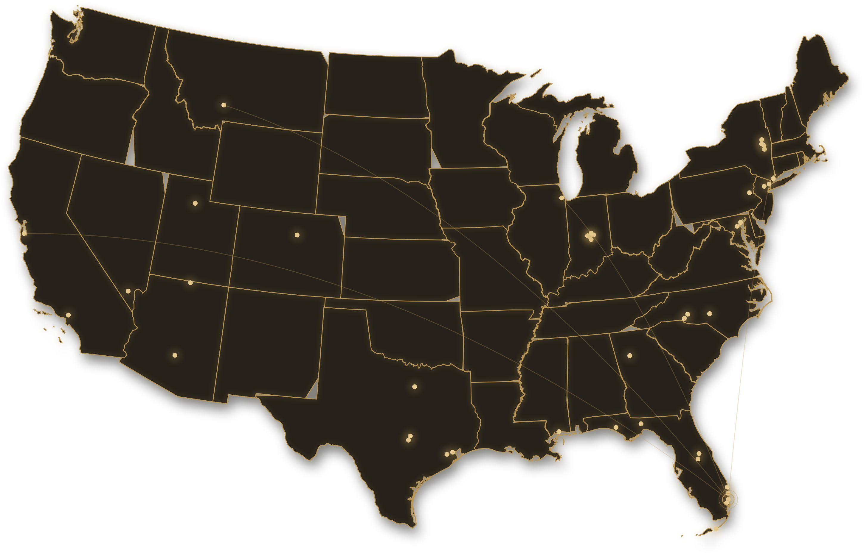
The Network — 34 Airport Markets · 100+ FBO Points of Sale · Home Base Fort Lauderdale
1 Make the Footprint Findable  Put Privato where its customers already search. Claim priority map listings under one retail name and secure visible mentions from the FBOs already served. | 2 Refresh and Relaunch the App  Browse en route or in the lounge — the order meets the aircraft before departure. The concept below, made real.
3 Lead with the Scarce  Selective skincare, boutique houses, and limited releases few others carry — offered where regulation allows. | 4 Open the Partner Channel  Turn formal aviation, hospitality, and event partner programs into a repeatable acquisition channel. Begin with programs that already accept partner applications.

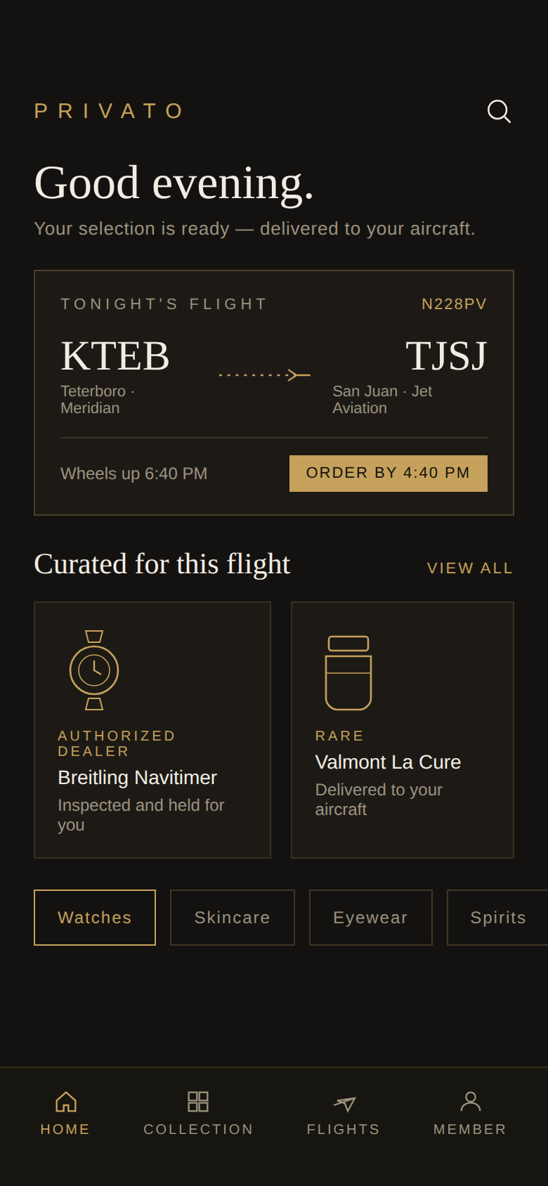 | 163  Brands Identified | 24  Differentiators | 100+  FBO Points of Sale | 0  Privato Google Listings | 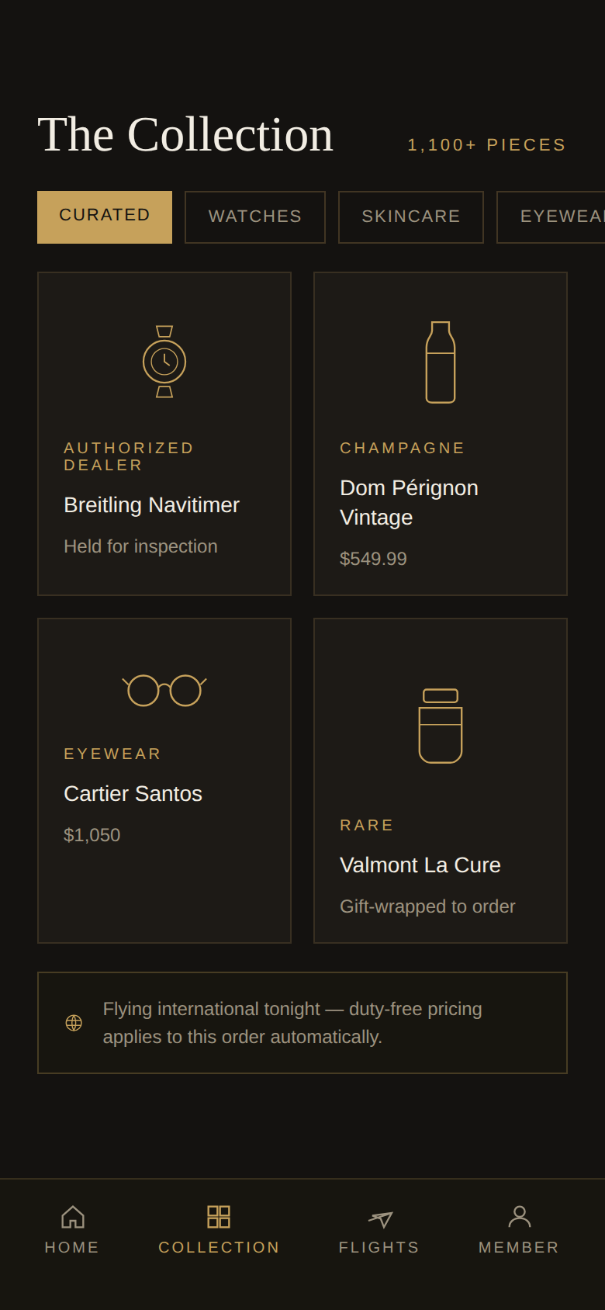
————
ULXI · Jonathan W Dimock · jwd@ulxi.com · Draft, for Discussion · August 2026
Companions: Retail Brand Report · Brand-Vendor-Location Matrix

